Coding, also referred to as programming, is the process of creating instructions for a computer to follow. These instructions are written in a specific language that the computer can understand. There are many different programming languages, each with its own strengths and weaknesses. Some popular choices include Python, Java, and JavaScript.

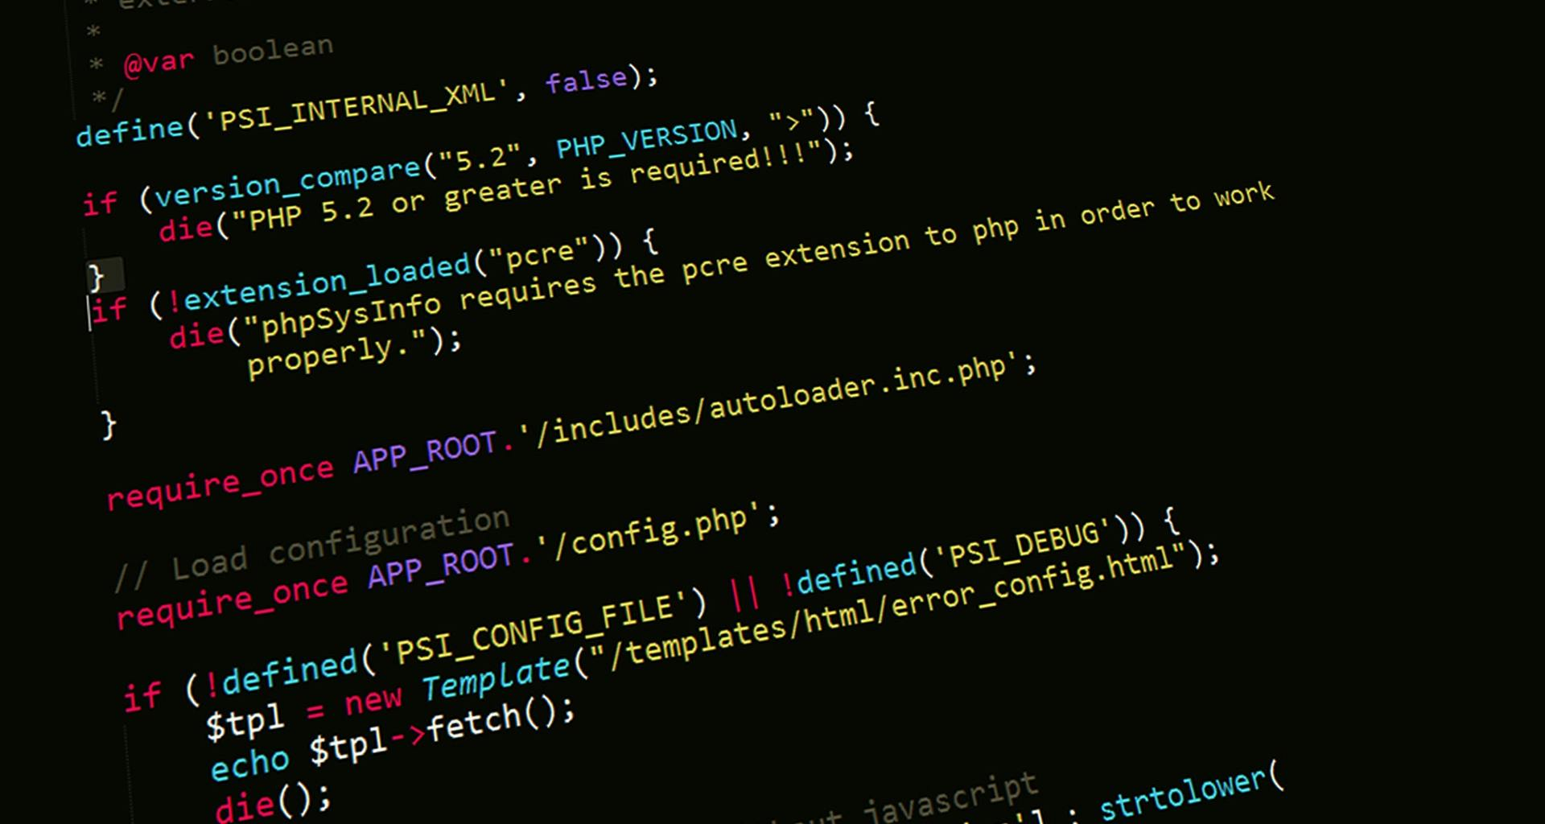

Coding can be used to create a wide variety of software applications, from simple websites to complex video games. It can also be used to automate tasks, analyze data, and control robots.

If you're interested in learning more about coding, there are many resources available online and in libraries. There are also many coding bootcamps and courses that can teach you the basics. With a little effort, you can learn to code and create your own software applications.